### SSO Amazon Cognito Configuration.

1. Log in to the AWS portal as an admin user [here](https://portal.aws.amazon.com/billing/signup)
2. Search & Select “Cognito” service.

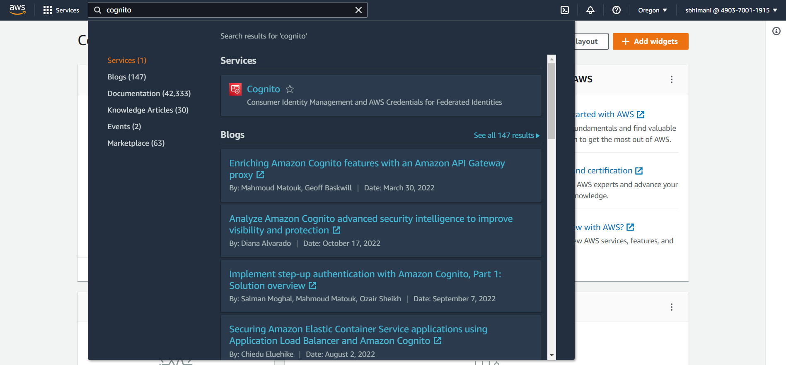

* 1. Click on “Manage User Pool”

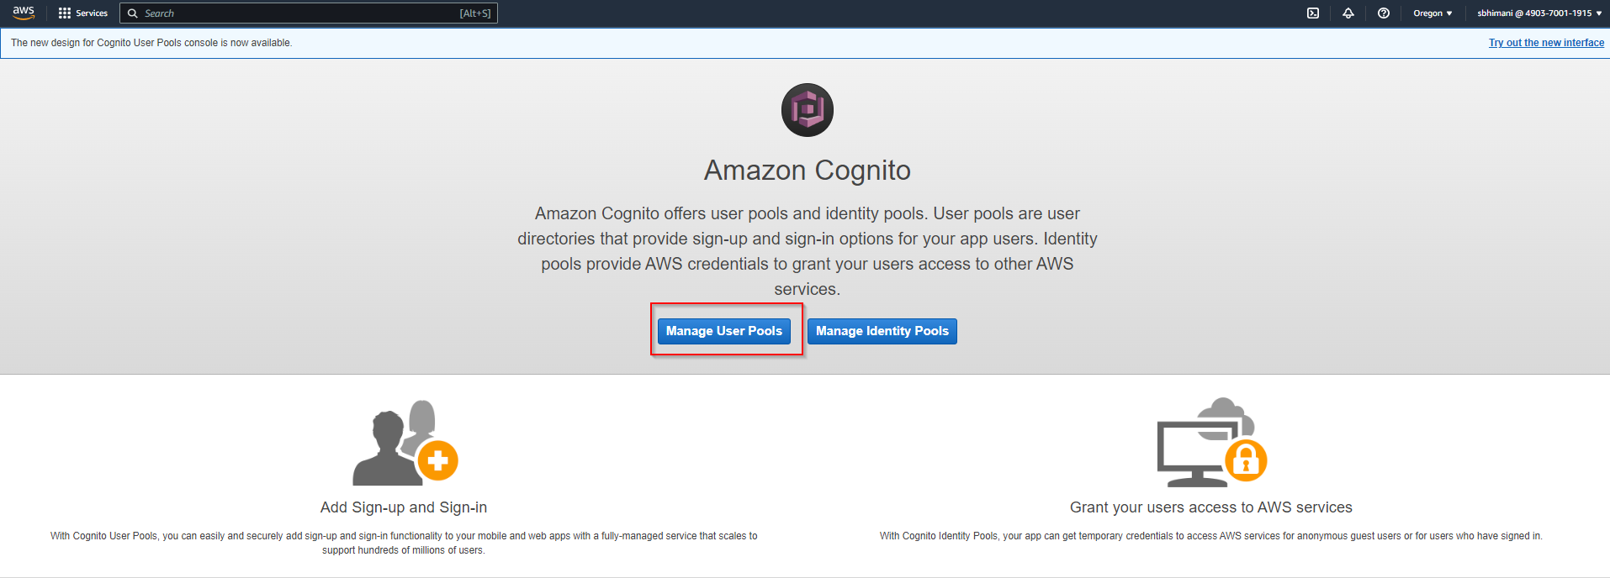

* 1. Click Create User Pool

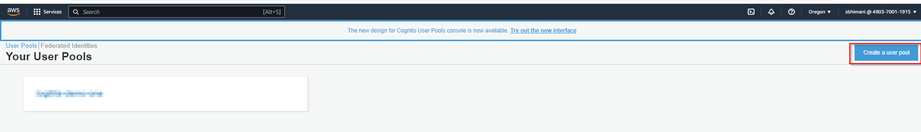

* 1. Follow the instructions [here](https://docs.aws.amazon.com/cognito/latest/developerguide/cognito-user-pool-as-user-directory.html) to create a User pool
     1. Below we have an image of a sample user pool

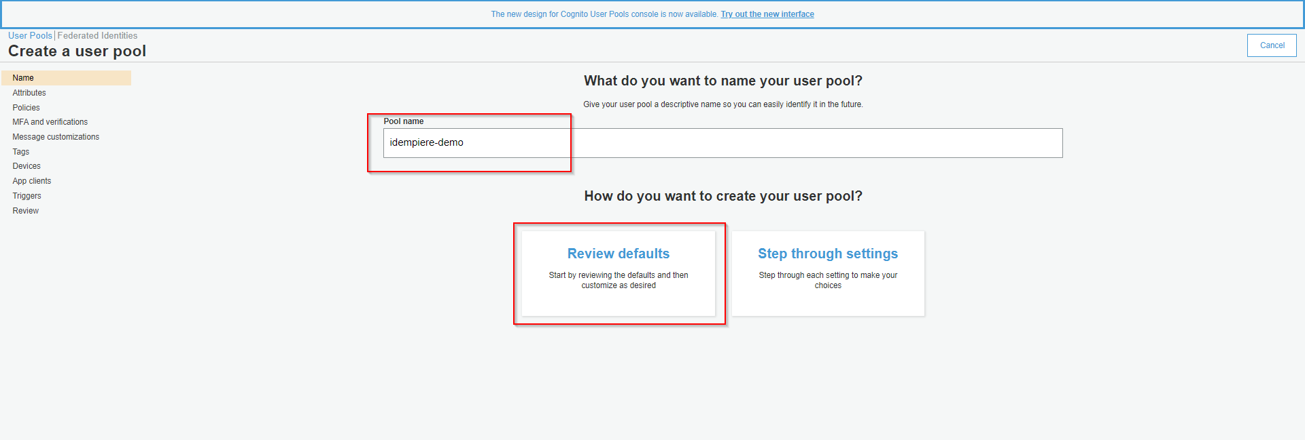

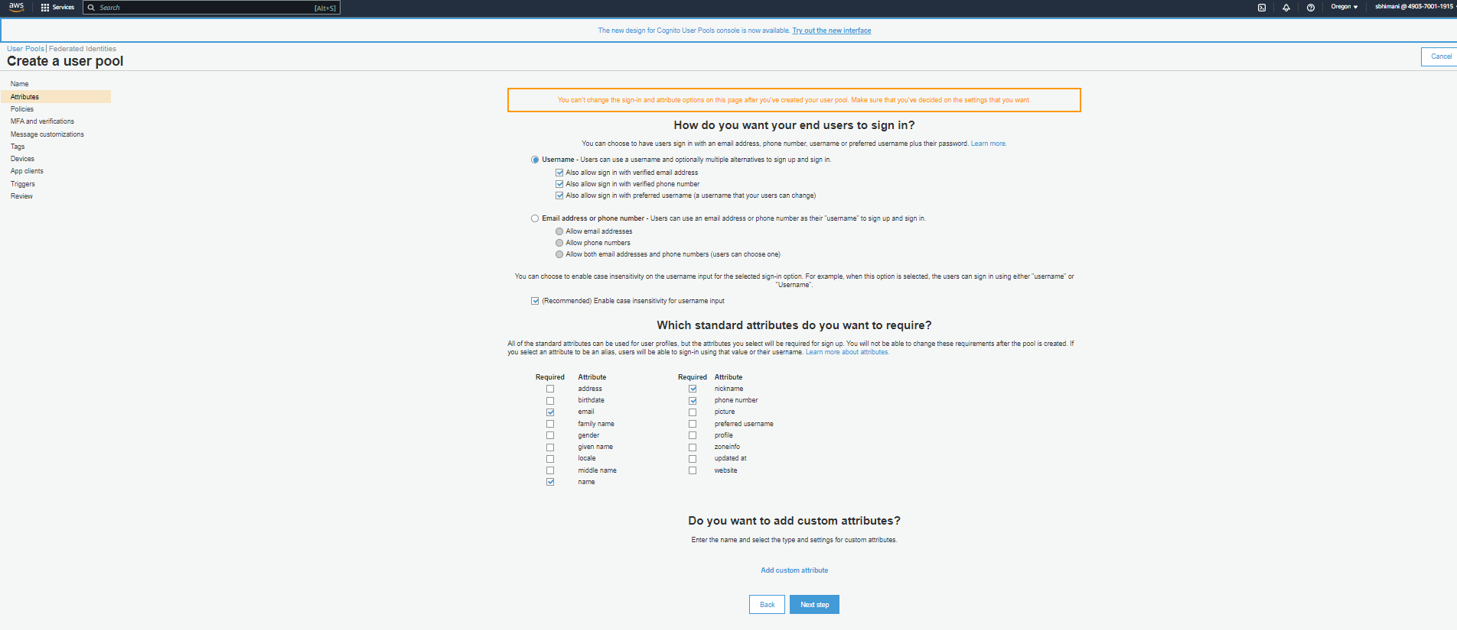

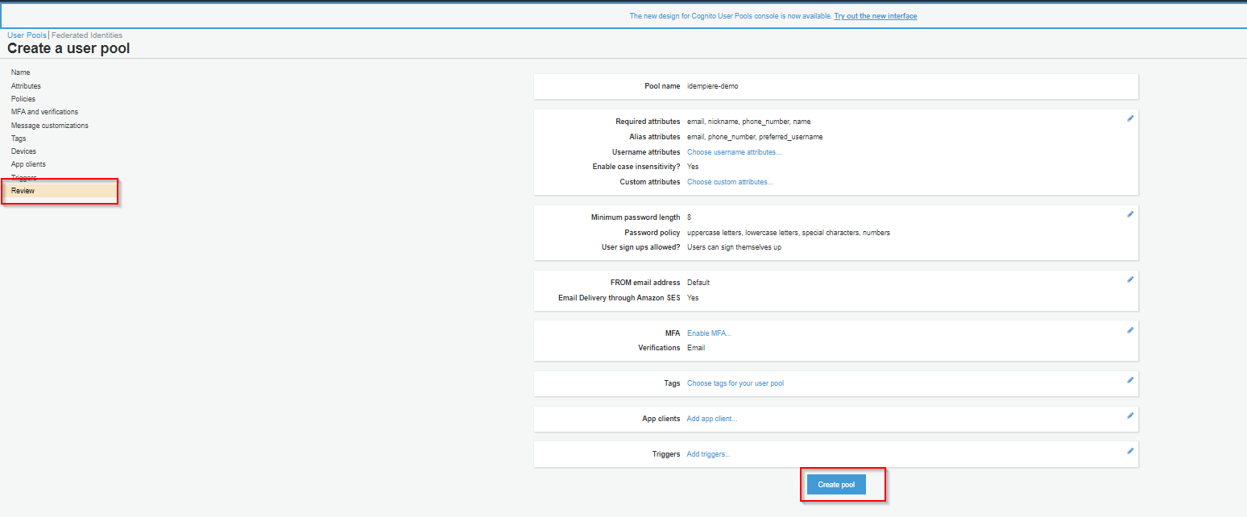

* 1. Follow the instructions [here](https://docs.aws.amazon.com/cognito/latest/developerguide/cognito-user-pools-configuring-app-integration.html) to Add an app client and set up the hosted UI

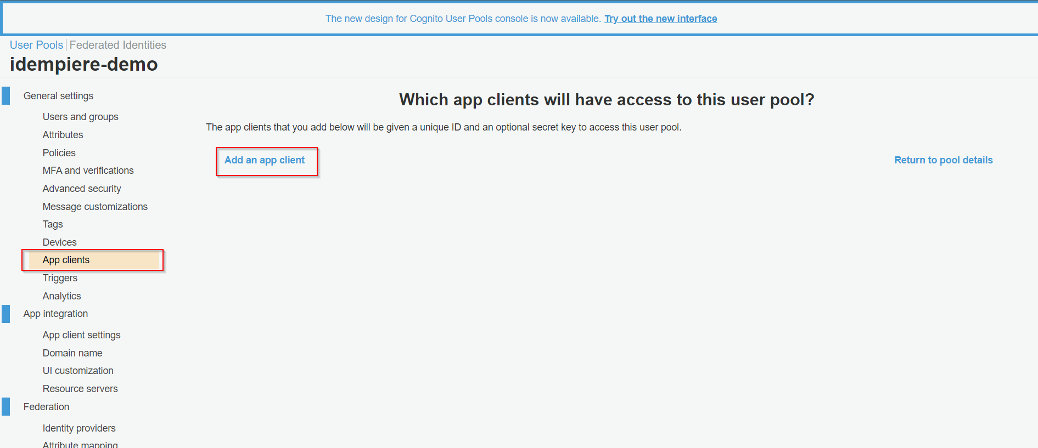

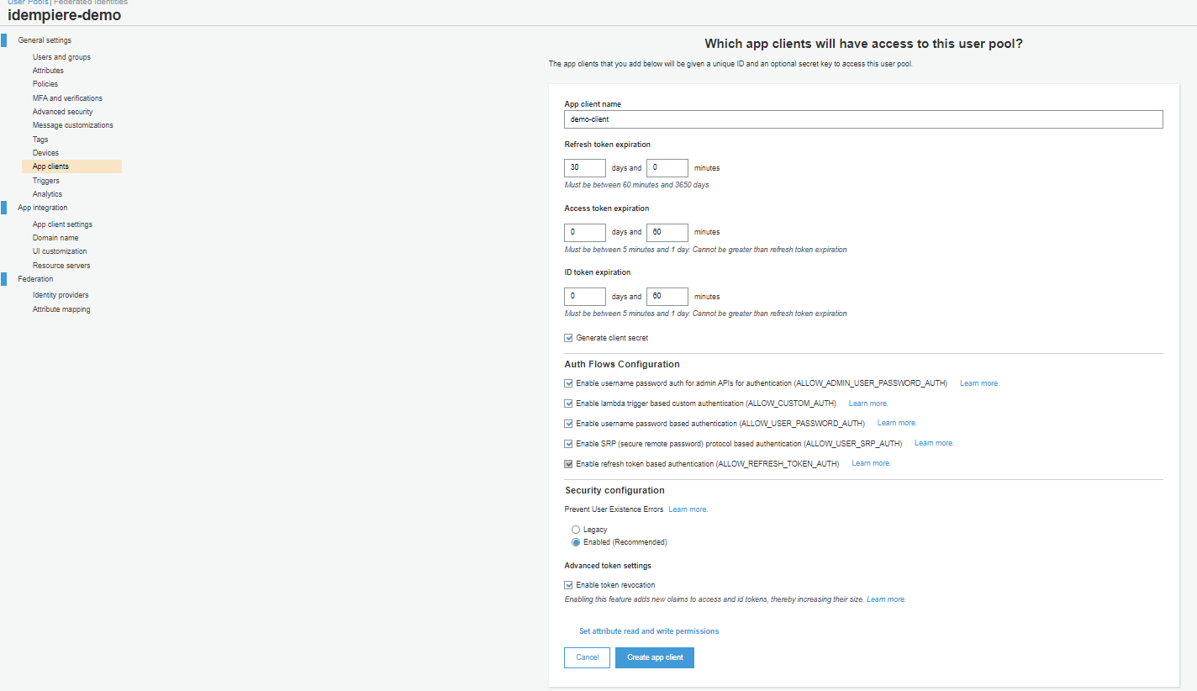

* + 1. Copy ‘App client id’
    2. Copy ‘App client secret’

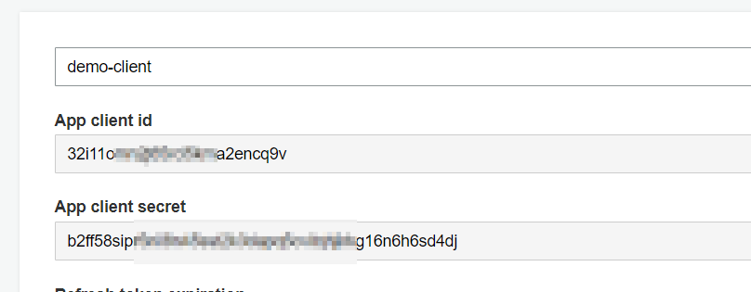

* 1. App client settings

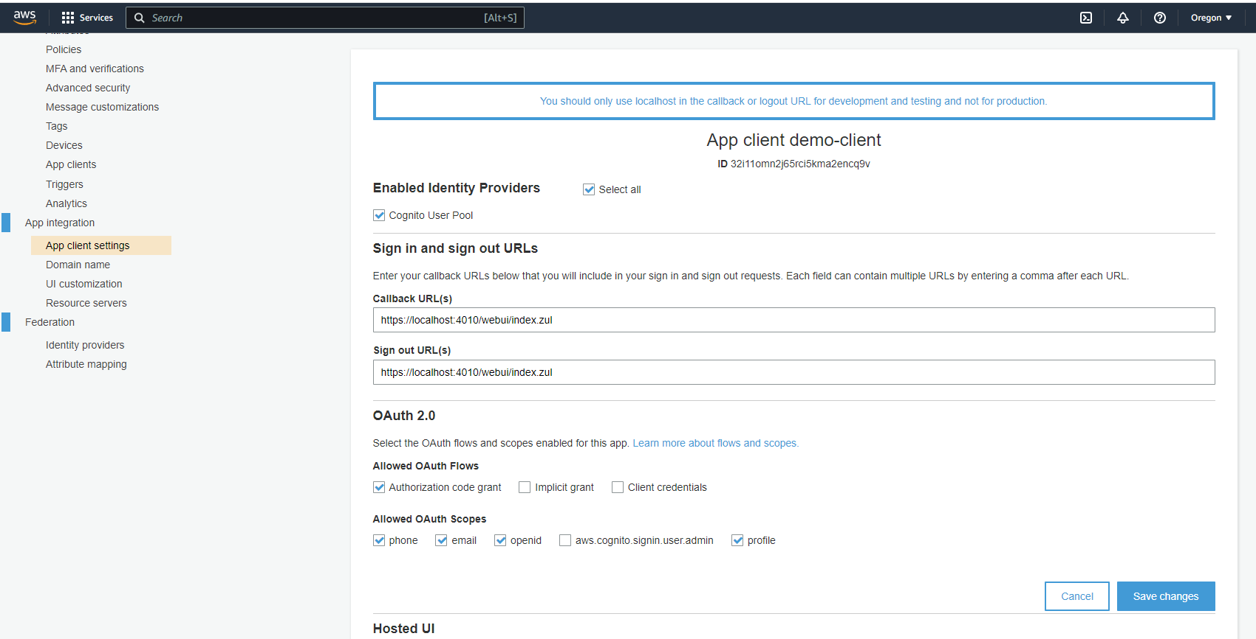

* 1. Domain name
     1. Copy ‘Amazon Cognito domain’
        1. E.g “https://idermpiere-logilite.auth.us-west-2.amazoncognito.com”

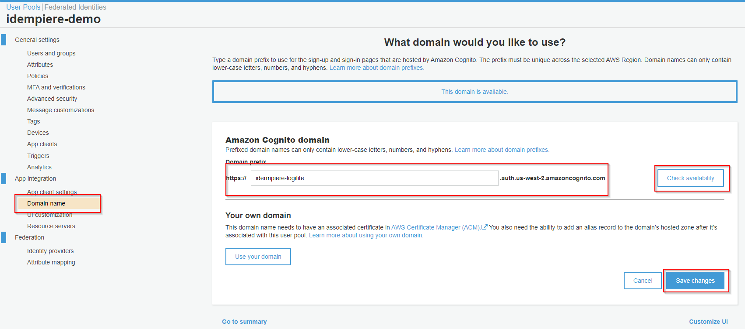

* 1. General setting
     1. Copy ‘Pool id’



### SSO IDempiere Configuration.

1. Log-in in iDempiere as a system user.
2. Open the “SSO Configuration” window and fill detail below
   1. SSO Provider ( Amazon Cognito as SSO Provider)
   2. Name = “Logilite-demo” ( You can give any name here, we are used the same as AD App)
   3. Tenant ID (You can find in your app at User pools > General setting > “**Pool Id**”)
   4. Application Client ID (You can find in your app at User pools > General setting > app clients > “**App client id**”)
   5. Application Secret Key (User pools > General setting > app clients > “**App client secret**”)
   6. Application Redirect URIs (You can find the URL in your app User pools > App integration > app clients settings > “**Callback URL(s)**”)
   7. Application Logout URL(You can find, it in your User pools > App integration > app clients settings > “**Sign out URL(s)**”)
   8. Application Domain (You can find, it in your User pools > App integration > “**Domain**”)
   9. Application Discovery URI (https://cognito-idp.*Region*.amazonaws.com/*your user pool ID*/.well-known/openid-configuration)
      1. *Region = You can find it by clicking Oregon*

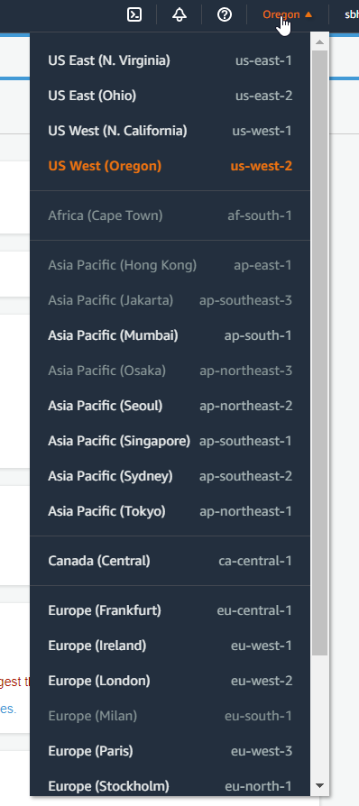

* + 1. *your user pool ID =* Tenant ID
  1. Default (true - Indicate that current config is used for SSO login)
     1. Note:- Only on SSO configuration can be a default at a time.
     2. For [more info](https://docs.aws.amazon.com/cognito/latest/developerguide/cognito-userpools-server-contract-reference.html)

